**Designing and developing the static travel blog website:**

* **Plan Your Website:**

Decide on purpose, target audience, and content you want to showcase on your travel blog**.**

* **Choose a Domain Name and Hosting:**

Select a domain name that represents your blog and find a web hosting provider to host your website**.**

* **Select a Website Builder or Framework:**

You can use static site generators like Jekyll, Hugo, or simply HTML/CSS for manual coding.

* **Design Your Website:**

Create a visually appealing design that complements your travel theme. Consider using a responsive design to ensure your website looks good on all devices.

* **Create Content:**

Write engaging travel blog posts and gather high-quality images to accompany stories.

* **Optimize for SEO:**

Optimize your website for search engines by using relevant keywords and meta tags.

* **Set Up Navigation:**

Create a user-friendly menu and navigation structure for easy access to your content.

* **Implement Social Sharing:**

Add social media sharing buttons to encourage readers to share your posts**.**

* **Include Contact Information:**

Make it easy for readers to contact you if needed.

* **Test Your Website:**

Thoroughly test your website to ensure it functions properly and looks good on various browsers and devices.

* **Publish Your Website:**

Upload your website to your hosting provider.

* **Backup Your Website:**

Regularly back up your website to prevent data loss.

* **Monitor and Update:**

Continuously update your content and monitor website performance.

* **Promote Your Blog:**

Share your blog on social media and engage with your audience.

* **Consider Monetization:**

If desired, explore ways to monetize your blog through ads or affiliate marketing.

Remember to keep your website user-friendly and focused on providing valuable travel information and stories.

**Design the website layout using HTML and CSS:**

**Certainly! Here's a basic example of a simple travel blog website layout using HTML and CSS. You can customize it further to fit your specific needs.**

**```html**

**<!DOCTYPE html>**

**<html>**

**<head>**

**<title>My Travel Blog</title>**

**<link rel="stylesheet" type="text/css" href="style.css">**

**</head>**

**<body>**

**<header>**

**<h1>My Travel Blog</h1>**

**<nav>**

**<ul>**

**<li><a href="#">Home</a></li>**

**<li><a href="#">Destinations</a></li>**

**<li><a href="#">Blog</a></li>**

**<li><a href="#">About</a></li>**

**<li><a href="#">Contact</a></li>**

**</ul>**

**</nav>**

**</header>**

**<section class="main-content">**

**<article>**

**<h2>Exploring the Beaches of Bali</h2>**

**<img src="bali.jpg" alt="Bali Beach">**

**<p>Lorem ipsum dolor sit amet, consectetur adipiscing elit. ...</p>**

**<a href="#">Read More</a>**

**</article>**

**<article>**

**<h2>Hiking in the Swiss Alps</h2>**

**<img src="swiss.jpg" alt="Swiss Alps">**

**<p>Lorem ipsum dolor sit amet, consectetur adipiscing elit. ...</p>**

**<a href="#">Read More</a>**

**</article>**

**</section>**

**<aside>**

**<h2>Popular Destinations</h2>**

**<ul>**

**<li><a href="#">Paris, France</a></li>**

**<li><a href="#">Tokyo, Japan</a></li>**

**<li><a href="#">Machu Picchu, Peru</a></li>**

**<li><a href="#">Santorini, Greece</a></li>**

**</ul>**

**</aside>**

**<footer>**

**<p>&copy; 2023 My Travel Blog</p>**

**</footer>**

**</body>**

**</html>**

**```**

**And here's a basic CSS (`style.css`) to style this layout:**

**```css**

**body {**

**font-family: Arial, sans-serif;**

**margin: 0;**

**padding: 0;**

**}**

**header {**

**background-color: #333;**

**color: #fff;**

**text-align: center;**

**padding: 10px;**

**}**

**nav ul {**

**list-style: none;**

**}**

**nav li {**

**display: inline;**

**margin-right: 20px;**

**}**

**.main-content {**

**display: flex;**

**justify-content: space-between;**

**padding: 20px;**

**}**

**article {**

**width: 45%;**

**border: 1px solid #ddd;**

**padding: 10px;**

**margin: 10px;**

**}**

**article h2 {**

**font-size: 1.5em;**

**}**

**aside {**

**width: 25%;**

**background-color: #f4f4f4;**

**padding: 20px;**

**}**

**footer {**

**text-align: center;**

**background-color: #333;**

**color: #fff;**

**padding: 10px;**

**}**

**Create engaging content with captivating photos and travel stories:**

**Creating engaging content for your travel blog involves sharing captivating photos and compelling travel stories. Here’s an example of a travel blog post:**

**Intro:**

Nestled in the heart of Japan, Kyoto is a city that seems to have preserved time within its ancient walls. From the moment you step off the train and into this historical wonderland, you’re transported to a world where tradition and modernity coexist harmoniouslyTitle:*A Magical Journey Through the Heart of Kyoto**\***

Witness the charming alleyways and hidden corners of Gion, revealing the rich history and cultural significance of this enchanting neighborhood led us through the historic streets, sharing the secrets of geisha culture and tradition. The highlight was a personal encounter with a maiko, where we witnessed her graceful dance and had the opportunity to ask questions about her life. This tour seamlessly combined history, culture, and personal experiences, making it a must-do for anyone visiting Kyoto. It’s a magical journey that left us with unforgettable memories!

My journey then led me to Kyoto, a city steeped in history and elegance. The tranquil beauty of the bamboo forest in Arashiyama left me awe-inspired, the towering green stalks creating a sense of serenity and magic. Visiting the golden pavilion of Kinkaku-ji was a surreal experience, the golden exterior shimmering in the sunlight against the backdrop of the perfectly manicured gardens.

The Bamboo Forest:

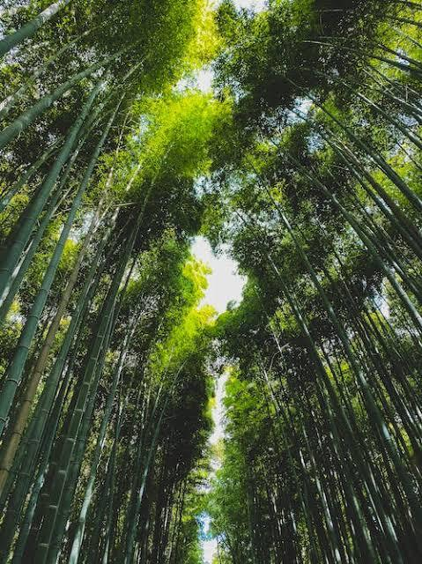

As you wander through the towering bamboo groves of the Arashiyama Bamboo Forest, you can’t help but feel a sense of serenity. The tall, swaying bamboo shoots create a surreal atmosphere, and the gentle rustling of leaves becomes a symphony of nature.

**Kinkaku-Ji Temple:**

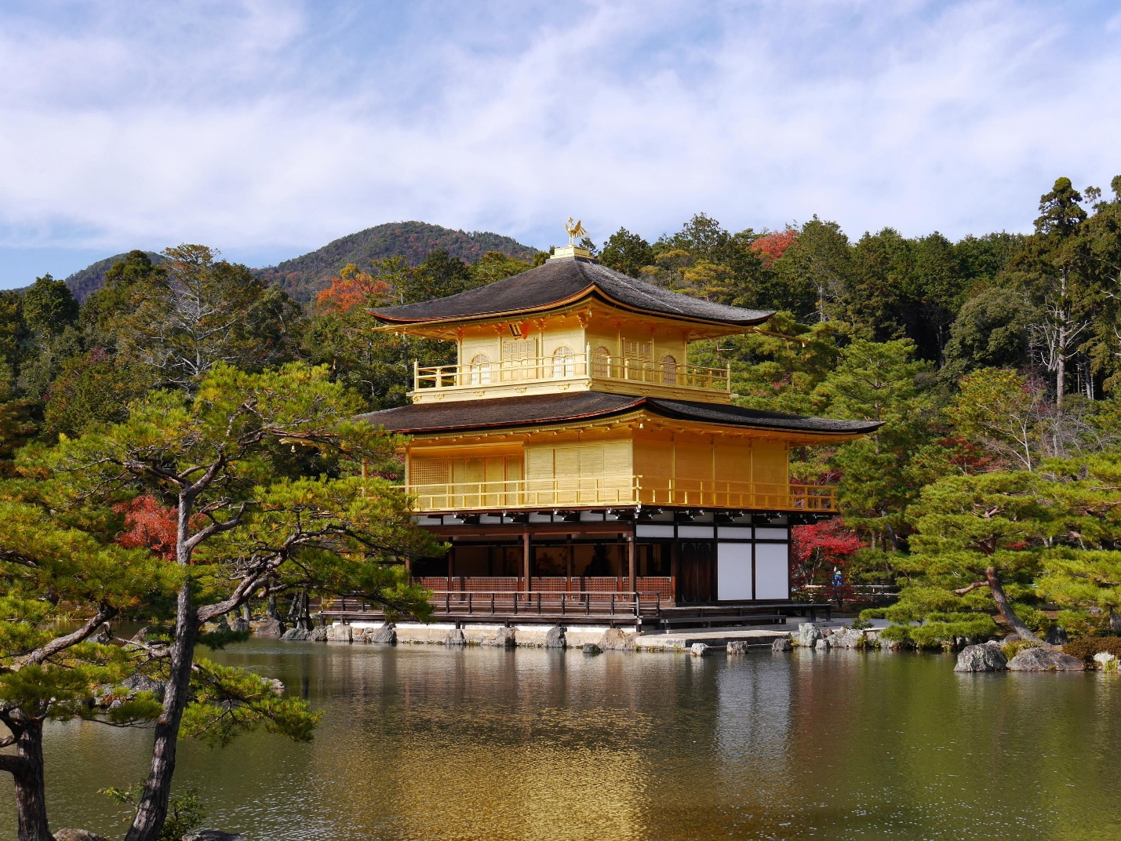

The stunning Kinkaku-Ji Temple, also known as the Golden Pavilion, glistens like a jewel in the sunlight. Its intricate gold leaf covering shimmers in the reflection pond, making it one of Kyoto’s most iconic landmarks**.**

**Tea Time in Gion:**

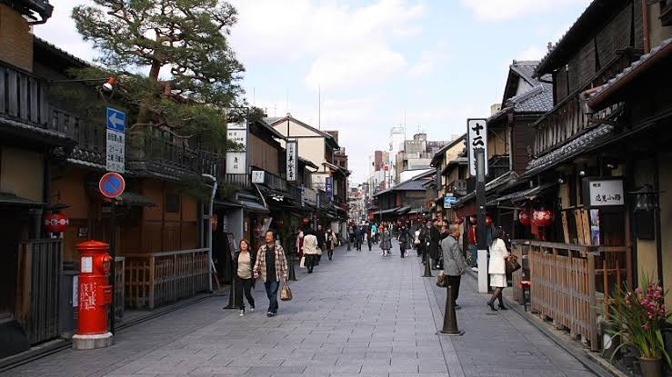

Exploring the historic Gion district, you might catch a glimpse of a geisha gracefully making her way to an appointment. Pause for a traditional tea ceremony in a charming teahouse, and you’ll be immersed in the rich culture of Kyoto.

**Sunset at Fushimi Inari Taisha:**

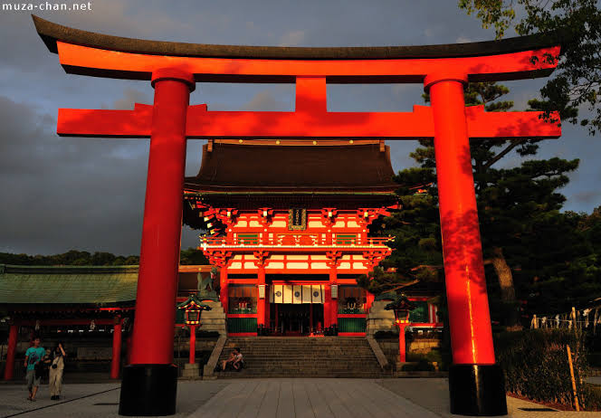

The vermilion gates of Fushimi Inari Taisha create a mesmerizing tunnel that leads you to the summit of Mount Inari. The hike to the top is well worth it, as the view of Kyoto at sunset is a sight to behold.

**Conclusion:**

Kyoto is a city that captures the essence of Japan’s history and culture. With its enchanting landscapes and timeless traditions, it’s a place that leaves a lasting impression on every traveler. So, when you plan your next adventure, make sure Kyoto is on your list.